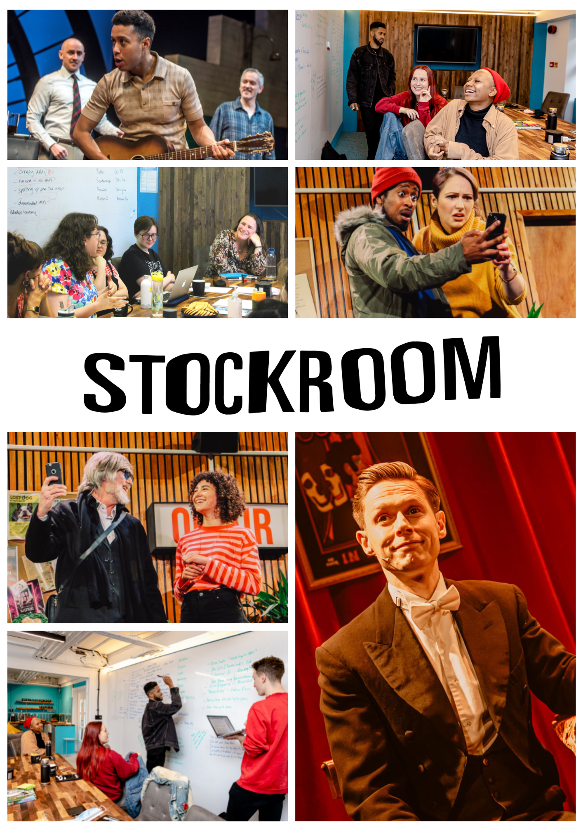

Operations Assistant Recruitment Pack

Thank you for your interest in the Operations Assistant role at Stockroom. This is a full-time, permanent position based at our Islington office.

As the Operations Assistant, you will be responsible for the day-to-day operational and financial administration at Stockroom, including managing our office and creative spaces. Alongside this, you will support the administration needs of all Stockroom staff.

Stockroom

Stockroom produces new work for the stage. We tour to theatres around the country, bringing communities together with stories that unite us around our basic humanity. Our commitment to making work designed to travel to theatres around the UK is historic and enduring.

We work with artists from all backgrounds to deliver the best writing, sharing quality work around the country and the world.

We work with partners, creatives and audiences from a range of backgrounds, in a variety of locations, to develop new live art experiences for the midscale stage.

We want to harness the creativity found throughout the country and contribute to culture locally in the places that we visit.

We put the audience first in every piece we create while remaining true to our traditions of high quality and politically motivated theatre.

We believe that this approach will allow people across the country to be part of creating and also experiencing the highest quality new work for the midscale.

The Writers Room

Stockroom has always created some of the best new work in the country and we want to carry on this tradition by helping to create the next generation of theatre makers and contribute to a new, diverse canon. To this end we have invited six writers - Stockroom Artists - onto our staff, who write together, focusing on making mid-scale work for audiences across the country.

While the content of our work might not always be immediately political, the process behind it is. We believe strongly in social justice and work hard to maintain a diverse and open creative space, working with creatives from all backgrounds, but focusing on those who have socio-economic barriers that make it hard for them to work as an artist in this industry.

Operations Assistant

Terms: Full time, permanent.
Hours: 40 hours per week. Office hours are generally 09.30 am - 5.30 pm Monday to Friday. Due to the nature of the job there will be some evening and weekend work to be agreed in advance. Overtime is not paid in respect of extra hours worked, but TOIL can be agreed in advance with your line manager.
Salary: £28,000 per annum.
Start: Flexible - as soon as possible.
Report to: General Manager
Location: Stockroom offices at 38 Mayton Street, London N7 6QR.
Holiday: 20 days per annum, plus 8 statutory holidays and an additional minimum of 3 days of company holiday to be taken on specific dates.
Probation period: 3 months.
Notice period: 1 months.
Pension: Stockroom contributes 5% of basic salary towards a company pension scheme (Aviva) that is available to all staff upon successful completion of their probationary period.
Additional: Gym membership available.

The Operations Assistant will ensure the efficient day-to-day running of Stockroom and all Company administrative needs.

This role is at the heart of the company and we are looking for someone who is organised, proactive and welcoming. You will need to support all aspects of what we do to make sure that things run smoothly and push us all to be a better company.

You will be committed to diversity and equality in the arts, and the power the arts have to bring people together. You will be an excellent communicator with an ability to manage multiple deadlines with a flexible approach to problem solving.

Key Responsibilities

Office management

- Open and close the building each day, and ensure that the office is well-looked after and welcoming.
- Receive visitors and be the first point of contact.
- Develop and maintain systems to manage room and space bookings; welcome visitors.
- Answer phones, open the post and deal with general enquiries.
- Manage office contracts and relationships with service providers, ensure value for money.
- Maintain up-to-date contact lists.
- Order supplies for the building.
- Assist members of staff with IT support
- Work with our cleaner and landlord.

General administration
- Work with the whole team to keep the company diary up-to-date
- Support with the organisation of meetings, including sending documents on time and taking minutes at meetings as required.
- Support the Executive Team with diary management.
- Organise travel arrangements as required.
- Provide support with recruitment and HR.

Fundraising Administration
- Maintain relationships with our regular donors
- Create and monitor database of all donors
- Research and sign up to appropriate websites and mailing lists
- Submit initial application forms for appropriate funding, keeping schedules of deadlines and application windows
- Gather and report on equal opportunities activity

Finance administration
- Code supporting paperwork for all financial transactions, ensuring that correct sign-off is received for purchases.
- Make use of Xero accounting software to support bookkeeping
- Reconcile all financial transactions quickly and carefully
- Produce sales invoices
- Support processing the weekly payroll for company members, including dealing with questions from HMRC and pension providers.
- Manage the office petty cash fund
- Support the preparation of Year End accounts.
- Maintain the filing system for financial documents.
- Pay cheques into the bank.

General
- Be committed to artistic excellence.
- Act in the best interests of Stockroom
- Promote the principles of Arts Council England’s Creative Case for Diversity in Stockroom’s work.
- Implement Stockroom’s policies, those relating to diversity, inclusion and access.
- Perform any other duties as reasonably required by Stockroom.

Person Specification

We will ask you to show your suitability for the role in the areas below in both the application and interview.

Essential
● A highly organised, proactive and driven person
● Excellent communication skills
● Good written and numeracy skills
● Excellent attention to detail
● Confident time management and the ability to prioritise tasks while working quickly and accurately
● The flexibility and interpersonal skills to work in a small team
● A commitment to diversity and equal opportunity
● A desire to learn and develop

Desirable
● An interest in theatre
● Knowledge of Xero software

Applications

At Stockroom, we are committed to making the theatre industry more representative of contemporary Britain. We want to specifically encourage applicants from those who experience barriers and inequality due to their race, gender identity, disability and/or and socio-economic background.

We will offer individual feedback to all unsuccessful candidates who we interview. We unfortunately do not have the capacity to offer individual feedback to applicants who are not shortlisted for interviews.

If you have any questions about Stockroom, the role, the application, the interviews, or require this pack or any further information that will support you applying in a different format, please get in touch with us: jobs@stockroom.co.uk.

Key Dates
Application Deadline Sunday 11th September 2022, 7pm
Shortlisting Complete Mon 12th September 2022
1st Round Interview w/c 19th September 2022
2nd Round Interview w/c 26th September 2022

Please let us know in your application if you are not available on the interview dates above.

To apply, please email an up-to-date CV with the names and email addresses of two referees to jobs@stockroom.co.uk by Sunday 11th September at 7pm.

In addition to your CV, we ask that you also provide some supplementary information in which you let us know who you are, why you want to work with Stockroom, and which aspects of the Operations Assistant role you are particularly interested in.

The supplementary information could take the form of:
● a cover letter (no longer than two A4 pages)
● a video or audio recording (no longer than 5 minutes)

You will be prompted to fill out an equal opportunities form once you have sent your CV and supplementary document. This will not form part of your application.

Interviews

The 1st round interview will last approximately 25 minutes and will help us get to know you better. This will take place on in our offices at 38 Mayton Street.

The 2nd round interview will have a practical element that will reflect the tasks you’re likely to undertake as part of the role. We will conduct these in-person at our offices and you will compensated £100 for your time.

